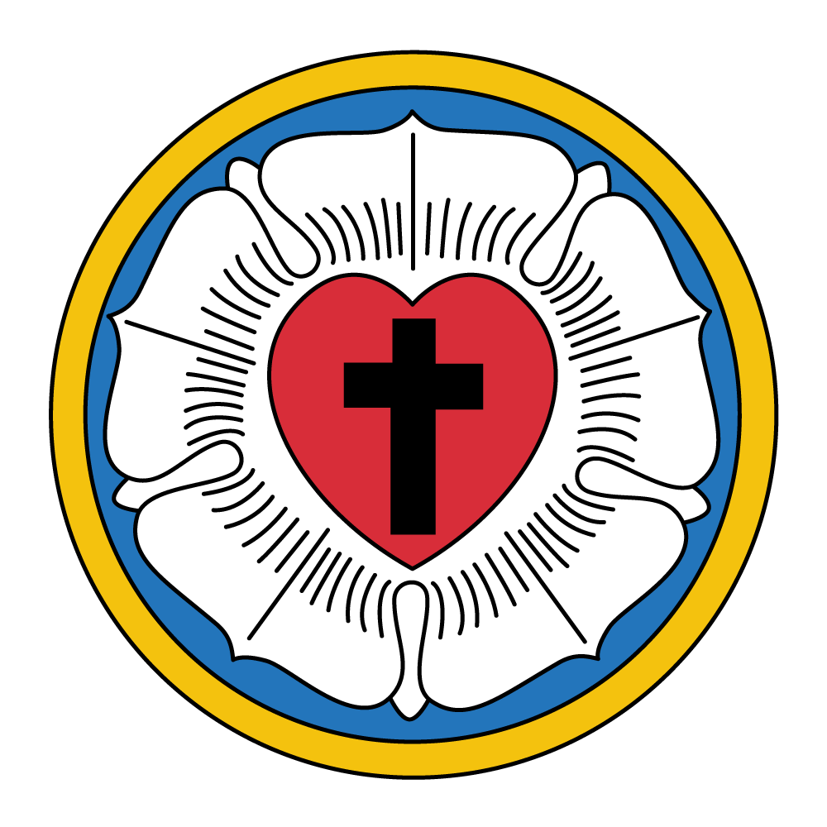
A Study of Lutheran Church History
in North America



Lutheranism in North America

Sunday Morning Adult Bible Study

Introduction: Historiography and Background

A Brief Survey of Lutheran History

Questions of Historiography: Where Do We Begin?

Lutheranism in Early and Colonial America: 1619-1700

The Lutheran Church Takes Root in America

1700-1818

From Germany to America: Pietism, Pastors, and Palatines

The First Lutheran Synod in America

Lutherans in Georgia?!
  - The Patriarch of Lutheranism in America: Henry Melchior Muhlenberg

Muhlenberg and Social Issues of the Day

The Pennsylvania Ministerium

Lutheranism in America after Muhlenberg
  - Timeline of Important Events: 1700-1818

The Roaring 1820’s: Expansion and Growth in American Christianity
  - What’s going on with the Lutherans in the 19th century?

New Hope Dawns for Lutheranism in America

Introduction: Historiography and Background

A Brief Survey of Lutheran History

1. When did the first Lutherans arrive in North America?
A. 1619
B. 1839
C. 1560s

2. The first Lutherans to arrive in North America were primarily German.
True or False

3. When was the constitution of the Lutheran Church-Missouri Synod signed?
A. June 25, 1847
B. April 26, 1847
C. October 30, 1847

4. Who was the first President of the Missouri Synod?
A. Martin Stephan
B. Wilhelm Löhe
C. Carl Ferdinand Wilhelm Walther

5. Which seminary was the first to be organized in the Missouri Synod?
A. Concordia Seminary, St. Louis, MO
B. Concordia Theological Seminary, Fort Wayne, IN

6. The majority of the Saxon immigrants in 1839 settled in:
A. Perry County, MO
B. Ebenezer, GA
C. The Delaware River Valley

7. Which description best fits your knowledge of Lutheran history in North America?
A. I could be a seminary professor of church history!
B. A conversation over coffee would sum it up.
C. Why on earth did you ask me these questions!?

Questions of Historiography: Where Do We Begin?

In any study on church history, the question is immediately raised: “where do we begin?” It is not as simple as the famous song says, “start at the very beginning, it’s a very good place to start.” In that case, we could start at the Reformation. Historical studies of Lutheranism in America can be broken up chronologically, institutionally, theologically, or thematically. Regardless of the approach, we must ask ourselves the question that every student of history must seek to answer: what does this particular section of history have to do with us as Christians today?
The quantity of information available on the topic of Lutheranism in America is extensive. This study of Lutheranism in America will highlight both the chronological progression including significant events, people, places, and theological issues.
Some of the questions we will examine are: Where did Lutheranism in America begin? What led to the arrival of Lutherans in America? How did they continue to hold to the confession of faith as a church of the Reformation or did they? What is and has been the effect of Lutheranism upon the American culture and vice versa? How did the LC-MS begin and arrive where she is today?
Also, one of the goals in this study is to provide introductory insight into key people, events, places, and theological matters of both the LC-MS and Lutheranism in America, broadly speaking. The study will also teach us how Lutheran history has impacted this congregation, the synod, and the church catholic. Therefore, it is also a study of what a Lutheran confession of faith means today in our particular context and corner of history. If sayings such as, “history repeats itself,” and “you must know your past to know where you are going,” etc. are true, then there is value in exploring our history.
A study in history is also an interpretation; albeit one that is based upon facts both written and recorded. We seek: 1) to interpret events in history, paying close attention to the historical context and seeking to apply our knowledge and interpretation of history in our lives today as we consider the present affairs in the church; and 2) look to the future as the church continues the struggle to remain faithful to the Confessions and to her Lord awaiting the consummation of the Church triumphant for all eternity.
Ultimately we know that all of human history belongs to the Lord and He graciously works all things for His good purpose of life and salvation, regardless of how events might seem at any given time: human history, the good, the bad, and the ugly, belongs in hands of our Heavenly Father. Lutheran church history in America is no exception.
The United States has a long and rich heritage of people and cultures, which have grown from fledgling European colonies, to the birth of a young nation, and developed, into one of the world’s largest and most powerful nations. In many and various ways, American culture has been intertwined with Christianity in America. We will focus mainly on Lutheranism in America. Therefore, one primary question will remain in the foreground throughout this study: Where does Lutheranism fit in the story of American Christianity? Is it contrary to American history and contributions? Is it woven intimately with American Christianity and culture? Is it completely isolated from culture and Christianity in America?

- Based upon our introduction so far, what are some challenges that arise for us as we begin a Bible study on the topic of Lutheran church history in America? How do we address these obstacles in order to benefit from studying history?

- Briefly look at Hebrews 11. Also, read 12:1-2; how does the author of Hebrews study Old Testament history and apply it to his readers? How can we apply Hebrews 11-12 to a study of church history? How will this aid our understanding of our Lutheran forefathers in America?

- Why is it important as Lutherans to study church history, broadly speaking? What then is the value for focusing our study on a particular piece of history, Lutheranism in America and LC-MS history?

- How would you answer the question posed at the ending paragraph of the introduction material?

- Based upon your own curiosity, interests, and the discussion so far, what questions might you have about Lutheranism in America that you would like answers to?

Lutheranism in Early and Colonial America: 1619-1700

The first mention of Lutherans in North America is a case of mistaken identity. A Spanish general by the name of Peter Menendez killed a group of French Huguenots in Florida in the 1560s. He said it was against the Luteranos. However, this was a common name used for Protestants in general; no Lutherans were harmed in the actual events.
The real first encounter of Lutherans in North America was a Danish expedition in 1619, including Swedes, Danes, and Norwegians. They were attempting to locate the Northwest Passage and got stuck in Hudson Bay in July of 1619. Included in this group were Captain Jens Munck and a chaplain, Rev. Rasmus Jensen. Rev. Jensen conducted regular worship services for the crew. These were the first Lutheran services held in Western Canada, if not in North America altogether. Life in the colony went well until Christmas when scurvy and led poisoning plagued the colony, killing all but three. Captain Jens Munck was one of the three survivors.
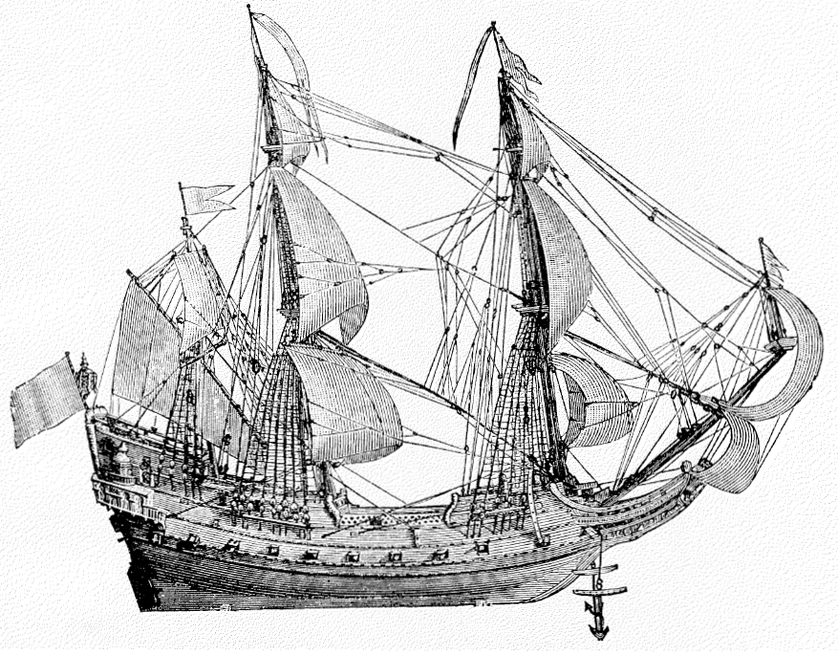
The first Lutherans in America did not organize themselves into synods immediately upon arrival in the new world. The early colonial years of American history did not see a massive influx of Lutheran settlers—at least not in the same quantity as the Puritans and Dutch Reformed and other Calvinist branches of Christianity, and later the Anglicans.
A drawing of Jens Munck’s boat
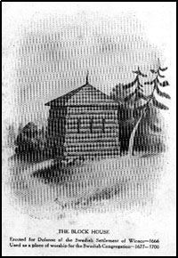
A recurring theme in early Lutheran American history is the struggle for identity and establishment. Settlers to the new world faced many struggles as they colonized America. Challenges abounded for all Christians, especially Lutherans in these early years. First, there was a lack of pastors. This was not the rosy high profile place to go to in the 1600s. Men had to volunteer to come to America. There was no Lutheran seminary in America until 1826. Second, the use of language complicated communication between Lutherans of different ethnicities and caused tension with the increasing number of English speaking Christian churches. Third, numerous theological issues arose involving unionism, the Lord’s Supper, a lack of pastors, doctrinal minimalism, and to what extent would Lutherans subscribe to the Confessions of the Lutheran Church. It is safe to say that colonial life in America was chaotic for Lutherans.
However, there are some notable communities and figures in the early Lutheran history of America. The picture on the left is “Old Swedes church” located in Philadelphia built in 1669. From 1637-1655, the Swedes also established Fort Christina in present day Wilmington, DE, where oldest church building still standing as it was originally built is located (1698). New Sweden also boasted the first Lutheran pastor to settle in America, Reoris Torkillus (1639-1643), and the first missionary work done by Johann Companius (1601-1683), who translated Luther’s Small Catechism into Lenni-Lenape, the language of the Delaware Indians.
The Swedish colonies eventually fell to the Dutch in 1655. The English took over in 1664 and introduced Anglicanism into the colonies. Lutherans were scattered at this point and many joined the Anglican church due to an agreement of fundamental doctrines found in the Augsburg Confession and the 39 Articles of the Anglican church.
Similar challenges faced Dutch Lutherans arriving in the 1630s in New Amsterdam (1621). However, the theological struggle was more intense during these years because the Dutch came with a state sponsored confessional position: Calvinism. One Director General of New Netherlands was particularly hostile to Lutherans: Peter Stuyvesant. He did whatever he could to deter Lutheran gatherings using political rulings to compel them to join the Reformed confession.
One Lutheran pastor displayed heroic behavior despite the oppression from Reformed authorities. Johannes Gutwasser, a pastor to Dutch Lutherans, was confronted by the Reformed authorities upon arrival, and forbidden to preach and teach among the Lutherans, but he successfully avoided them for two years before he was arrested and deported in 1659.
When Lutheran groups were able to establish themselves, it was increasingly difficult to support such congregations. There was no coherent pastoral organization or church organization yet, further complicating matters. Baptist Revivals began to pop up throughout the American countryside by the end of the 17th century and became increasingly popular in the 1700s as well, affecting Lutherans in rural areas. Finally, in 1690, a significant number of German immigrants arrived, primarily in Pennsylvania. William Penn declared that there would be no established church in that territory—thus, freedom in Christian worship.

- What are your observations, comments, or questions after taking a brief look at early Lutheranism in America? Based upon the readings from the last page and a half, what do you observe so far about life as an early Lutheran in America?

- What challenges or controversies mentioned in early American Lutheran history might be particularly helpful for us as Lutherans in today’s context?

- How do you see God’s work in history despite the many challenges that faced the first Lutherans in America? What hope does that give us? Cf. Matthew 16:18.

The Lutheran Church Takes Root in America

1700-1818

From Germany to America: Pietism, Pastors, and Palatines

Following the wake of the Thirty Years’ War (1618-1648) in Germany, a theological movement known as pietism emerged. Many thought that the emphasis upon orthodox teaching within Lutheranism and strict doctrinal adherence to confessional writings throughout Europe were significant factors in the Thirty Years’ War. Pietism, which quickly spread throughout Germany and influenced Lutheranism in America, became the response to the golden age of Lutheran orthodoxy. Philip Jacob Spener (1635-1705) is known as the founder of German pietism. Ordained as Lutheran pastor in 1666 he became increasingly aware of many problems plaguing the church. In 1675 Spener published a book entitled Pia Desideria (Pious Wishes), which entailed his critique of Lutheran orthodoxy in Germany.
Johann Arndt
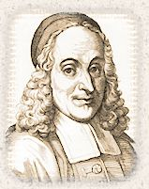
While many of Spener’s criticisms were justified; e.g., an increase in polemical writings between Christians of different confessions, poorly educated pastors and laity, a lack in homiletical excellence, and an increase of rationalistic theology – his teaching caused great conflict within Lutheranism and also spread to other church bodies. Several dangers resulted from pietism and Spener’s teaching: 1) an emphasis on “deeds not creeds” led to doctrinal minimalism and ultimately to religious indifference; 2) the focus on experiential faith deemphasized the importance of the Sacraments within the life of a Christian; 3) pietism looked for a noticeable conversion experience and would openly presume to judge Christians as converted and unconverted upon the basis of works, not the content of faith; and 4) a hyper-emphasis on sanctification in the Christian life ignoring and undermining the “solas” of the Reformation.
In the midst of doctrinal controversy in Germany, the town of Halle became a hotbed for pietism; its seminary sent many pastors to America. August Hermann Francke (1663-1727), a confidant of Spener, became the director of the seminary at Halle; he also sent two brothers, Justus (1672-1723) and Daniel Falckner (1666-ca. 1741), to America. Justus and Daniel were first involved in land surveying. Then, in 1703, Justus Falckner became the first Lutheran pastor to be ordained in America. This was truly a unique situation: a Swedish Lutheran pastor in the New York area ordained Falckner who was a German, using a Latin language rite, so that he could serve Scandinavian Lutherans. Justus Falckner is also credited with publishing the first Lutheran Catechism in America (1708). “By the time of Falckner’s death in 1723, fourteen congregations in New York and New Jersey depended on his leadership.”
Both the harsh winter of 1708-1709 and religious conditions in Europe brought another significant population of Germans to America. These Germans came from the Palatinate in southwestern Germany and included many Lutherans who were served by Pastor Joshua Kocherthal until his death in 1719.
The early 1700s brought promise and hope to Lutheranism in America. With the ordination of Falckner and the work of other Lutheran pastors in the colonies, congregations began to form. More Lutherans, especially Germans, began to arrive in America bringing with them their cultural and religious heritage. Soon after, these congregations began to seek the initial steps in forming synods with neighboring Lutheran congregations.

- Paul instructs both Timothy and Titus to “follow the pattern of sound words and to be in accord with sound doctrine” (2 Timothy 1:13; Titus 2:1). Read 2 Timothy 4:1-5. How can Paul’s instructions to Timothy apply to the danger of pietism’s doctrinal indifference regarding the pure teaching of Scripture? How does this better inform the teaching that goes on within our congregation?

- Based upon the brief explanation of pietism, what does Spener suggest that is beneficial for the life of the Church?

The First Lutheran Synod in America

In 1721, William Berkenmeyer (1687-1751) arrived in the Hudson Valley. He assumed the work that Justus Falckner had done in the congregations of New York and New Jersey. Berkenmeyer was an exceptional example of a decidedly orthodox Lutheran pastor. For Berkenmeyer, being Lutheran meant a clear confession of God’s gifts through Word and Sacrament, subscription to the Unaltered Augsburg Confession of 1530, and a quia subscription to the entire symbols of the Lutheran Confessions as expressed in the 1580 Book of Concord. In his service as pastor he sought to organize a synod utilizing the consistory model from Europe. On January 25, 1736, the General Church Order was signed by Berkenmeyer and other pastors in the Hudson Valley combining both Dutch and Germans into a synod. While only one meeting has been recorded, their attempt at organization marked the first Lutheran synod to establish a constitution in America. The fact that Berkenmeyer was concerned with articulating the pure Lutheran teaching of the Reformation drawn from Holy Scripture is also encouraging given the lack of confessional Lutheran presence in Germany and America at the time. The following are quotations from Berkenmeyer’s constitution.

“Chapter One, treating of the doctrine which shall be proclaimed in all our congregations.
Article One. All called preachers of the congregations shall regulate their teaching and preaching according to the rule of the divine Word, the Biblical prophetic and apostolic writings, also according to our Symbolic Books, the Unaltered Confession of Augsburg, its Apology, the Smalcald Articles, both Catechisms of Luther, and the Formula of Concord; neither should they teach or preach, privately or publicly, anything against these [Confessions] nor even use any other new phrases which would contradict the same.”

- What are the chief concerns expressed in this article? What is the purpose of writing down a list such as the one above? What comparison can we make between what we have read of the document so far and Trinity’s constitution?

Chapter Four. “Article II. The preachers shall admonish the Christians four weeks in advance to prepare themselves for the Lord’s Table and that those who intend to commune should examine themselves well and not receive the holy Sacrament without sincere repentance and turning to God, but after Christian and brotherly reconciliation with their neighbor.”

- Read 1 Corinthians 11:27-29. How do these verses help support what is written in this particular article concerning the Lord’s Supper? How are we to examine ourselves before receiving the Lord’s Supper?

- Consider also the words of Luther’s Small Catechism on the Sacrament of the Altar, “Who receives the Sacrament worthily? Fasting and bodily preparation are certainly fine outward training. But that person is truly worthy and well prepared who has faith in these words: ‘Given and shed for you for the forgiveness of sins.’ But anyone who does not believe these words or doubts them is unworthy and unprepared, for the words ‘for you’ require all hearts to believe.”

“Article III. The young people who have not yet gone to the Lord’s Table or have not been sufficiently instructed in the Christian doctrine, and likewise such as have had burdens of conscience should be earnestly admonished that they should come to the preacher during the week to be examined in the Catechism and the chief parts of Christian doctrine and to be instructed in, and comforted with the Word of God; and private absolution shall not be denied them who desire it.”

- How is this practiced at Trinity? Why is catechesis important throughout the entire life of the Christian? Cf. Luke 1:1-4 and 1 Peter 3:15-16.

Lutherans in Georgia?!

The group known as the “Salzburgers” was a unique group of settlers to America. They came from the alpine region bordering Austria southeast of Munich. Many of the Salzburgers came to America seeking reprieve from the oppression of their Lutheran confession of faith in Germany. The Thirty Years’ War had ended with the Peace of Westphalia (1648) declaring the principle, “cuius regio, eius religio” which stated that the ruler of the region had the right to determine the religion that would be practiced there. For example, if one lived under a Roman Catholic prince, the region would be Roman Catholic; if a Lutheran prince, then the region would be Lutheran.
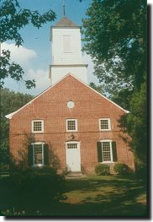
The region of Salzburg had long been ruled by the Roman Catholic archbishop acting as secular prince as well as a church official. There were many Lutherans in the area who had adopted the teachings of Luther since the time of the Reformation. Tensions increased throughout the second half of the 17th century. Then, Count Leopold Anton Eluetherius von Firmian became the archbishop and was overtly hostile to Lutherans and Protestants in the territory. This led to his edict on October 31, 1731 that all Lutherans without property were to leave the territory within 80 days and those who had property, within 3 months. As many as 30,000 faithful Salzburgers set out in search of refuge in Protestant regions.
The Lutheran Salzburgers were joined by Pastors Martin Boltzius and Israel Christian Gronau, both instructors of Latin at Halle. At first, the efforts in this new community seemed promising: a school and orphanage were established, a church building was completed in 1769, and they built the first water-powered mill in Georgia. However, the colony’s governance was dangerously close to a theocracy which entangled the pastors in primary leadership roles outside of worship and preaching. Initially the Salzburgers rejected the use of slavery. However, in 1750, slavery was established in the territory of Georgia and Pastor Boltzius succumbed to the system despite early disapproval. He thought “that slavery could be turned to a good end if used as an opportunity for evangelism.” Eventually internal conflicts and issues between pastors and the onset of the Revolutionary War contributed to a decline in the colony’s expansion.
Jerusalem Church, Ebenezer, GA

The Patriarch of Lutheranism in America:
Henry Melchior Muhlenberg

From the fall of 1732 to the spring of 1733, Pastor John Christian Schultze ministered to Lutherans in the Philadelphia area. While his stay was brief, his contributions to Lutheranism in America transformed the shape of the church for years to come. Pastor Schultze united the three German Lutheran congregations of Philadelphia, Providence (also called The Trappe), and New Hanover into a single parish known as the United Congregations in Pennsylvania. Schultze then returned to Germany and appealed for a pastor on behalf of the United Congregations. While there were many appeals from Lutherans in the new world, this appeal to Europe for a pastor was unique because it brought Henry Melchior Muhlenberg to America in 1742. The United Congregations was a cornerstone in the foundation of the Ministerium of Pennsylvania, organized in 1748.
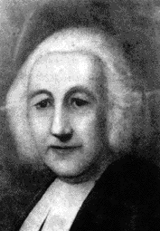
Henry Melchior Muhlenberg is known as the “Patriarch of Lutheranism in America.” He was born on September 6, 1711, and was educated in Göttingen, Germany. He eventually became a professor at the university in Halle. While he accepted the Book of Concord as the correct interpretation of Christian doctrine drawn from Holy Scripture, he also was influenced at Halle, a known center for Lutheran pietism which influenced his theology and church practice. Although, when attacked later in life with the charges of false teaching and unchristian conduct, Muhlenberg defended himself, saying,

“I herewith challenge Satan and all his servile, lying spirits to prove against me the least point that would be repugnant to the teachings of the apostles and prophets and our symbolic writings…Again and again I have stated orally and in writing that…in our Confessions I have discovered no error, blemish, or defect.”

He was ordained in 1739 just three years before coming to Philadelphia. Muhlenberg’s appeal to Halle for pastors brought more men to shepherd the congregations in the area and through his travels to various congregations in the colonies he created a bond between congregations and pastors in Pennsylvania and elsewhere. The following two quotations are excerpts from Muhlenberg’s journal:

“Saturday. [New Hanover, 27 November 1742] …I learned in private conversations that the congregation here was very much confused and dismembered. Some were attached to Schmid; others had separated themselves because of Schmid’s scandalous life; others had long since withdrawn and would have no more to do with churches or parsons because conditions had for a long time been so wretched and slovenly; still others had joined the Moravian Brethren, etc. Many believed nothing and some had been drawn into numerous sects, etc. Some had married and begotten children and had never been baptized, nor ever been to the Lord’s Supper, etc.”

“Saturday. [Philadelphia. 17 April, 1762]. Again instructed the confirmands in the morning. At two o’clock in the afternoon the adult members of the congregation assembled, and I examined the confirmands in the presence of the congregation. After they had given satisfactory and pleasing answers, I had them renew their baptismal covenants and promise faithfulness, whereupon I confirmed them, those present being deeply affected…”

Muhlenberg was just the man needed to organize the Lutherans scattered throughout the colonial territory surrounding Philadelphia. He was young, ambitious, and a brilliant scholar bringing a vision of unity to the Lutheran congregations, that until his arrival had little or no contact with one another. Muhlenberg took as his motto Ecclesia Plantada: the church must be planted. In addition to his work with the United Congregations Muhlenberg also opened a school with each of the congregations, providing a system of Christian education that focused the character of the Lutheran Church and her schools upon the teaching of God’s Word.
In addition to his work in America, Muhlenberg continued to keep in contact with Halle in order to supply the Lutheran congregations with pastors. This resulted in Muhlenberg’s famous Halle Reports which consisted of letters and diary entries from his work in America. From 1743 to 1747 Halle sent many pastors to America at the request of Muhlenberg including Rev. Peter Brunnholz and a catechist named John Nicholas Kurtz, whose ordination took place in the same year as the formation of the Pennsylvania Ministerium.

Muhlenberg and Social Issues of the Day

One of the major social issues at the outset of Muhlenberg’s arrival in America was the issue of African slavery in the colonies. Upon arrival in Charleston, South Carolina in 1742, he encountered slavery for the first time. As noted in the history of the Salzburgers, slavery was at first forbidden in southern colonies, such as Georgia. However, as labor demands increased, so did the request to import slaves. Many of the Salzburgers, such as Pastor Boltzius who had originally abhorred slavery, later came to accept it. Muhlenberg’s first encounter with slavery was met with great skepticism:
“I wonder if it will not produce severe judgments if people who pretend to be Christians use their fellow creatures, who have been redeemed along with themselves, as mere body slaves and do not concern themselves about their souls. This the future will show.
During subsequent years Muhlenberg and other German-speaking Lutherans instructed, baptized, and united in marriage numerous slaves in many colonies.” Despite his disapproval of slavery, his own son, Peter, owned several slaves and Muhlenberg himself was once offered the gift of a slave but refused.
When the Revolutionary War began, many Lutheran pastors, such as Muhlenberg, did not take active leadership in politics. Muhlenberg struggled with whether a Lutheran could support the war and whether or not it was a “just war.” Ultimately the question, “Is the king resisting the spread of the Gospel?” led him to become an opponent of the war. Although, his position was more neutral because he regarded politics to be outside his public call as a pastor. “Muhlenberg set a good example in keeping politics out of the pulpit. He admonished his fellow ministers that repentance and faith and godliness are the most direct means of strengthening and healing the body politic.” There were many Lutherans, such as Peter and Frederick Muhlenberg, who were more actively involved. Peter gave up his pastorate in Virginia and became a colonel and lieutenant-general in the army. Frederick later left his work as a pastor to become the first speaker of the United States House of Representatives.
As a result of the war, many Lutherans’ connection with Europe began to dissolve. Lutherans of all ethnic backgrounds began to develop an American identity as the young nation grew from colonial territories into the United States of America. For some Lutherans this was a simple application of the teaching on vocation: that a Christian serves God in whatever station He has placed them. The war was not as significant of an issue for German Lutherans as it was for the Anglicans since the Germans had little or no connection to England. Historian Abdel Ross Wentz states:
“The break of the colonies with England made little change in the relations of the Lutheran churches in America. The German Lutheran congregations in the English colonies had no organizational ties with England or any of the German principalities from which they or their fathers had come…Very early in colonial America the Lutherans, unlike other churchly groups, had attained ecclesiastical adulthood.”
Once again, the work of Henry Muhlenberg is called to our attention. It is largely due to his work, and the work of many Lutherans before him, that provided a foundation for the organization of Lutheran synods and their future growth, which we shall see in the next portion of this chapter on Muhlenberg.

- What is Henry Muhlenberg’s primary concern in the social issues discussed above? How then might Muhlenberg’s example equip us to face social issues in the 21st century?

The Pennsylvania Ministerium

The word synod in its American use did not originate from Europe where synod was somewhat synonymous with a church council or diet. In America, synod became associated with “walking together” in doctrine and practice for the sake of serving the Gospel within a group of churches. Therefore, we also want to ask the question: what is a synod? Simplistically defined, a synod is a group of churches that form together with a common confession of faith in order to advance the work of the Gospel. Some of the primary purposes of a Lutheran synod are 1) to provide theological training of the indigenous population for the pastoral office, 2) to judge the credentials of the pastor who will teach and preach in the congregations of the synod, 3) to provide liturgy, hymnody, and other literature according to sound Biblical teaching and the pure doctrine of the Lutheran Confessions, and 4) to maintain and spread the teachings of Holy Scripture and the confession of Scripture’s doctrine in the 1580 Book of Concord.

The following are excerpts from Muhlenberg’s communion liturgy of 1748:

“The minister goes before the altar, places the bread and the wine in order, then turns to the congregation and says:
M The Lord be with you.
C And with thy spirit.
M Let us lift up our hearts.
C We lift them up unto the Lord.
M Holy, Holy, Holy, is the Lord of Sabaoth.
C The whole earth is full of His glory.

…The communion being finished, the pastor shall say:
O give thanks unto the Lord, for He is good: Hallelujah.
The congregation responds:
And His mercy endureth forever: Hallelujah.
Then the pastor says the following collect:
We give Thee thanks, O gracious God, our Heavenly Father, because Thou has refreshed us with these salutary gifts; and we humbly beseech Thee to strengthen us, through the same, in faith toward Thee, and in fervent love toward one another, through Jesus Christ our Lord and Savior. Amen.”

With the expansion of Lutheran churches in America, many Lutherans began to look to one another for mutual support in the work of the Gospel. Muhlenberg is most well known for uniting the Lutheran congregations in the Pennsylvania area into the first major Lutheran synod in America, the Pennsylvania Ministerium. In 1748, the confluence of three events brought about the opportunity for Muhlenberg to begin his Lutheran version of the American experiment – a new synod. On August 25, 1748, John Nicholas Kurtz was ordained and St. Michael’s Church in Philadelphia was dedicated. The Pennsylvania Ministerium was organized the next day. A constitution did not appear until after the Revolutionary War in 1781, but those attending were in agreement in matters of doctrine and practice, which had been enumerated in the ordination vows of Pastor Kurtz: “to teach in my congregation nothing, whether publicly or privately, but what harmonizes with the Word of God and the Confessions of the Evangelical Church.”
The Ministerium expanded quickly during the remainder of Muhlenberg’s life. It grew from six pastors and twenty-four lay delegates from ten churches in 1748 to approximately eighty-one churches under Muhlenberg’s care by 1771. Despite the fact that no meetings were held in the Ministerium from 1753-1760, this so-called “lag-period” eventually led to the formation of the constitution as well as a development of a Lutheran hymnal in America. With the onset of the Revolutionary war, correspondence between Muhlenberg and Halle was interrupted. This allowed the Lutheran churches in America greater freedom from Europe as both the American territory and the newly founded Ministerium expanded.

- Reflecting upon the main purposes of a synod discussed above, how does the Lutheran Church – Missouri Synod reflect those purposes in her service to the Gospel? How do we experience this here at Trinity?

- What kind of Christian freedom do we have when it comes to forming synods, church constitutions, and church polity? What other purposes for a synod might we add to the list?

- What are the benefits of a synodical form of ecclesiastical structure?

Lutheranism in America after Muhlenberg

After Muhlenberg’s death in 1787, a theological shift in Lutheranism began to take place in America. Even though the Lutherans of the 1700’s were taught at Halle and influenced by pietism, the Lutheran Confessions were of the utmost importance to Lutheran Christians, especially in forming church constitutions and synods, as we read about in Pennsylvania. Towards the end of the 18th century, the Book of Concord became less important in the life of the church. For example, the New York Ministerium formed in 1786 made no mention of the Lutheran Confessions in their constitution. In many Lutheran churches the shift in theology moved from an apathetic confessional stance to an anti-confessional one. Some of the factors that contributed to this were the new found freedom and autonomy both in American politics and religion, a decline in German immigration, an established identity as American churches rather than colonial, and the influence of other church bodies such as Methodism, which began to grow rapidly in the early 1800’s.
The other chief issue that led into the 19th century was the question of language. The use of English in church resources became a theological issue when the common question asked was, “Is English adequate to communicate Lutheran theology”? In addition to the controversy, the simple pragmatic concern of acquiring English resources was a challenge for Lutherans in the 19th century.

- Read Galatians 3:27-29. In terms of the language we use in expressing Christian theology, what insight do Paul’s words to the Galatians offer us? Cf. 1 Corinthians 9:19-23.

Timeline of Important Events: 1700-1818

1703 – Ordination of Justus Falckner, first
Lutheran pastor ordained in America. 1708/1709 – Immigrants arrive in America from the Palatinate in SW Germany.
1721 – William Berkenmeyer arrives in the
Hudson valley. 1714 – J.S. Bach appointed concert master for the orchestra of the Duke of Weimar.

1731 – Salzburgers evicted from their territory in Germany by the Roman archbishop
1734 – Lutheran Salzburgers arrive in GA.
1735 – John & Charles Wesley arrive in GA.
1742 – H.M. Muhlenberg arrives in America.
1742 – Handel’s Messiah debuts.
1748 – PA Ministerium organized.
1748 – First Great Awakening (revival).

1758 – Jonathan Edwards dies.

1775/6 – American Revolution begins.

1776 – American Declaration of Independence.

1783 – American Revolution ends.
1786 – NY Ministerium organized.
1787 – Muhlenberg dies. 1787 – U.S. Constitution drafted & signed.
1789 – French Revolution begins.

1794 – First telegraph message is sent.

1803 – NC synod organized.

1809 - Abraham Lincoln born.
October 25, 1811 – C.F.W. Walther is born.
1813 - Napoleon's army defeated at Waterloo.

1817 – Prussian Union declared.
1818 – OH synod organized.

The Roaring 1820’s: Expansion and Growth in American Christianity

From the late 18th century to the first half of the 19th century, European immigrants continued to pour into the newly born and thriving country of the United States. As a result, numerically Christianity began to expand rapidly from 1780-1860. This was true for all Christian church bodies and ethnicities. However, none were as influential in the formative years of America’s growth as the Methodists. In 1780 there were approximately 749 Congregationalist churches in America compared to the 240 Lutheran congregations. By 1820, Methodism had absorbed much of the Congregationalist membership and became the dominant Christian church body in America boasting roughly 2,700 congregations. Meanwhile, Lutherans increased in the growth of congregations to a number of 800. However, the most dramatic increase in the number of congregations, for both Lutherans and Methodists, happened from 1820-1860. Methodism still retained the largest “Christian church body” status with 19,883 congregations. But, within those 40 years, the number of Lutheran congregations jumped from 800 to 2,128.
This information might lead one to ask, “Why the sudden explosion of Methodism in America?” As we have discussed earlier in the study, coming to America meant a new perspective for many people not only in matters of their freedom of religion, but also in matters of civil liberties and life in the expanding frontier. The Methodist church had a polity that responded to the realities of life on the frontier. Theological training became an impediment for the clergy in their task of teaching the Gospel and was therefore minimized or nonexistent. The creeds and confessions were thought to be antiquated and obstructive to the Gospel and therefore not used or written. The call to be a pastor came not from a seminary or a church body as in the Lutheran tradition. Rather, a call for a pastor was based upon one’s “spirit” or enthusiasm and one’s ability to preach. This allowed the Methodists to establish a congregation and a pastor almost instantly.
Another factor in Methodism’s rapid growth was their focus on mission work. Circuit riders were sent out to carry the Gospel into both town and country where the frontier seemed to be further west every day. Perhaps the most influential factor in Methodism’s popularity was their theological emphases on man’s ability and cooperation in salvation and the stress on the individual Christian’s strength. These resonated well in the American mind, echoing such values as freedom, autonomy and choice.
This was the age of the revivals, the anxious bench, and the Presbyterian “Sacramental seasons” where Presbyterians from all over would come and listen to preaching and prayers for four days of preparation before the Lord’s Supper on Sunday. Eventually, the Lord’s Supper lessened in importance and the “seasons” focused upon robust preaching and an emotional and physical reaction from the hearers. This was especially true for the Methodist revivals where the ministers preached intentionally spirited sermons to evoke human responses. One can easily deduce how the group known as the Shakers came out of such events. As a result of the shift in practice and structure of the church polity, the Reformed bodies, broadly speaking, leaned more towards the Arminian teaching of free will with regards to man’s salvation than the strict five points of Calvinism.

- In a time of change in culture and Christianity what challenges existed for Lutheran congregations in the first half of the 19th century? What challenges from both the surrounding culture and other Christian churches do we face today in our Lutheran church?

- Having read the brief overview of American Christianity and the previous chapters on Lutheranism in America, how do you think the Lutherans responded to the explosion of Methodism and the changing landscape of American culture?

What’s going on with the Lutherans in the 19th century?

As the 18th century closed we noted earlier, following Henry Muhlenberg’s death, that Lutheran orthodoxy took a turn for the worse in America. Freedom of choice and the importance of the individual clashed with Lutheran theology, especially in the doctrine of original sin and salvation by grace alone through Christ alone. While it seemed grim for Lutheranism in America at the onset of the 19th century, there was one family in particular that stood as a shining light for Lutheran orthodoxy: the Henkel family.
Paul Henkel (1754-1825) was a missionary on the frontier sent by the Pennsylvania Ministerium. In 1806 he founded the Henkel Press (New Market, Virginia) and was known for printing orthodox Lutheran materials. For example, the first Book of Concord in English was published in 1851 from the family press as well as many German language books for children. From the family press many articles on the evils of revivalism were formulated and printed. Although he participated in preaching at a few revivals, Paul Henkel was disturbed by them and thought they were not of God. His attempts to calm the tide of the revivals with good Lutheran preaching appear to have been unsuccessful. However, his work in forming synods was quite successful. He was influential in the formation of the North Carolina Synod in 1803, the Ohio Synod in 1818 with the help of Johannes Stough (or Stauch), and the Tennessee Synod of 1820. As we learned with the Pennsylvania Ministerium, the early Lutheran synods were formed based upon geographical location. Beginning with the formation of the Tennessee synod, doctrinal disputes and agreements played a larger role in the future of how Lutheran synods would unite together.
David Henkel, Paul’s son (1795-1831), carried on the work of his father with the same vigor and appreciation for the Lutheran theology of the Reformation. David Henkel taught that the Formula of Concord is determinative for what it meant to be a Lutheran, especially Article Seven on the Lord’s Supper and article eight on the person and work of Christ. If there ever was a prodigy in Lutheran history, David Henkel fit the part. He was licensed to preach at the age of 17 and wrote several works considered to be in line with historic Lutheran theology. His treatise entitled The Heavenly Flood of Regeneration was dedicated to the regeneration of the sinner in the sacrament of Holy Baptism. He also wrote A Treatise on the Person and Incarnation of Jesus Christ also called Against the Unitarians, An Answer to Joseph Moore, the Methodist, and The Carolinian Herald of Liberty in which, “he asserted that Lutheran unity proceeds from a common confession of faith, not from the uniformity in matters such as forms of worship.” David, like his father, emphasized the unity of the Church with the internal confession of faith built upon the clear teachings of Scripture as found in the Book of Concord. This position led to controversy between the Henkel family and other prominent Lutheran figures at the time who were looking to formulate Lutheran synods on the grounds of an outward organizational structure rather than upon the Book of Concord and a strong Lutheran confession of faith.
The controversy that led to the formation of the Tennessee Synod came from doctrinal disagreements between David Henkel and Gottlieb Schöber (1756-1838). Schöber’s influence as president of the North Carolina Synod led it to seek fellowship with an ecumenical scope. Doctrinal minimalism and the least common denominator confession of Jesus as Savior were the basis for union with both Moravian and Episcopalian churches. He also modified theological positions on the Lord’s Supper by describing the real presence in vague terms and conveniently leaving out any Lutheran disapproval of false teachings on the Supper. David Henkel publicly denounced Schöber and eventually the Henkel family split off from the North Carolina Synod and formed the Tennessee Synod in a decidedly orthodox Lutheran confession adhering to the Unaltered Augsburg Confession.
The Henkels also vocalized opposition to the General Synod formed in 1820. The Henkels were concerned with the General Synod’s lack of confessional basis for agreement and their structure of centralized authority, especially in the establishment of a single treasury of the synod. Gottlieb Schöber and Johann Georg Schmucker (1771-1854) sought to bring the various geographical synods into a national body of Lutheran churches. The General Synod was to be formed by the Pennsylvania Ministerium, the New York Ministerium, the North Carolina Synod, the Ohio Synod, and the Synod of Maryland and Virginia. The main plans for the General Synod were to be theological education, mission work, and a hymnal. However in 1823, the Pennsylvania Ministerium backed out of the General Synod because it was “too Lutheran;” at the time, it was seeking union with the Reformed churches in the Pennsylvania area. The Ohio Synod also pulled out before the formation of the General Synod due to its centralized governance.
It appeared that the beloved General Synod of J.G. Schmucker and Gottlieb Schöber was doomed to fail. However, Samuel Simon Schmucker (1799-1837), the young son of J.G. Schmucker, became a prominent leader in the General Synod and was the first professor of the Lutheran Seminary at Gettysburg founded in 1826.

- Despite the turmoil and controversy surrounding the General Synod and Lutheranism in America, how do we see God providing for His Church in these troubled years of the 1820’s?

New Hope Dawns for Lutheranism in America

On September 27, 1817, Frederick William III announced the union of Lutheran and Reformed churches into one congregation in Prussia for the 300th celebration of the Reformation; this infamous event is known as the Prussian Union. At first this union was voluntary but eventually the union was to be subscribed as part of a pastor’s ordination vows. While Frederick claimed this was purely a civil ruling it had profound theological implications. The union caused the small confessional Lutheran movement at the time to burst forth with a slew of writings and vocal protests of the union. Klaus Harms issued his own 95 theses against the Prussian Union. The union also instigated a confessional reawakening for many Lutherans in Germany who would soon come to America with their strong confession in heart and mind.
Some of major players of the confessional movement that we will explore with more detail in the following chapters are: J.A.A Grabau (1804-1879), who started the Buffalo Synod in 1845; Wilhelm Löhe (1808-1872), a pastor in Neuendettlsau, Bavaria; Friedrich Conrad Dietrich Wyneken (1810-1876), a missionary in Indiana; and Martin Stephan (1777-1846), a pastor at St. John’s in Dresden, Saxony, who led the German immigrants up the Mississippi River to Perry County, Missouri. In that settlement in Missouri the future of our Lutheran Church Missouri Synod found its beginning filled with both controversy and hope.

- How were the events of the Prussian Union beneficial for the Lutheran confession of faith in Germany and later in America? In what ways do we see similar struggles today both inside and outside the church? What comfort do the confessional Lutheran leaders in the 1800’s give us today as the Church continues to face many struggles?

- One of the effects of the Prussian Union was joint communion between the Reformed and Lutherans in the union churches. Read 1 Corinthians 11:23-29. How does St. Paul’s teaching on the Lord’s Supper apply to the problems that Lutherans faced in the Prussian Union? What does this encourage us to do as a Lutheran congregation who celebrates the Lord’s Supper regularly?

The sources for this study are from a variety of materials including Vicar Schuldheisz’ class notes from “Lutheran Church in America” with Dr. Lawrence Rast (CTS-FW); Moving Frontiers, edited by Carl S. Meyer, (St. Louis: Concordia Publishing House, 1964); Lutherans in North America, edited by E. Clifford Nelson, (Fortress Press: Philadelphia, 1980); L DeAne Lagerquist’s The Lutherans (Connecticut: Praeger, 1999); Richard C. Wolf’s Documents of Lutheran Unity in America, (Minneapolis: Fortress Press, 1966); Walter O. Forster’s Zion on the Mississippi (St. Louis: Concordia Publishing House, 1953); Abdel Ross Wentz, A Basic History of Lutheranism in America, (Philadelphia: Muhlenberg Press, 1955). A bibliography, with additional resources, has been included at the end of the study. When appropriate, footnotes will cite specific quotations and sources.
An excellent book about American Christianity and the effects of church and state upon each other is by Nathan O. Hatch entitled, The Democratization of American Christianity.
There are basically 4 ways to answer this: A. yes, Lutheranism and American Christianity are intimately woven together. B. no, there is no connection whatsoever. C. yes it is, but… D. no it isn’t, but… One historian in the “yes” crowd is Abdel Ross Wentz (A Basic History of Lutheranism in America [Muhlenberg Press: Philadelphia, 1955]). In the preface and introduction of the book he proposes that Lutheranism is an integral part of American history with a reciprocal relationship between the two (p. v of the introduction).
Unionism: joint worship and Christian fellowship between churches who are not in doctrinal agreement with one another. This was a common problem in early American history of the Lutheran church and continues to plague many Lutheran church bodies to the present day.
The 39 Articles received final revision in 1571 by the Convocation of the Church of England. They were written by Matthew Parker who was commissioned by Elizabeth I to write the articles based upon a confession of faith drawn from both Lutheran and Reformed confessional writings, such as the Augsburg Confession.
The Dutch Reformed held tightly to the teachings of the Synod of Dort (1618) which upheld double predestination and the five points of Calvinism: TULIP = Total Depravity, Unconditional Election, Limited Atonement, Irresistible Grace, Perseverance of the Saints.
Both the Lutherans and Reformed wanted “regular” pastors. For Lutherans this was important because of their allegiance to the Augsburg Confession articles V and XIV concerning the “regular” call (rite vocatus) of a pastor. By “regular” pastor they meant that the pastor was to be theologically trained, examined, called, and ordained.
One might wonder, “Where have the Germans been?” The Thirty Years’ War (1618-1648) and a lack of unified government are primary reasons for an early absence of German immigrants.
One of the most well-known Lutheran theologians of the 17th century was Johann Gerhard (1582-1637), who wrote a dogmatic series of approximately 16 volumes in length. He is also known for his rich biblical and doctrinal sermons and brilliant devotional writings, including Sacred Meditations, which has been reprinted by Repristination Press.
Pietism certainly influenced its English cousin, Methodism, and also the Moravians.
Halle was known as a place of “institutional pietism.” The teachers here still held to a structure of organization which cannot be said of those involved in a more radical pietism where mystical elements were common.
Justus Falckner penned one hymn found in TLH, # 472 “Rise, Ye Children of Salvation.”
Lagerquist, 25.
The three main reasons for the Palatinate emigration were 1) devastation and suffering from the Thirty Years’ War, 2) the severity of the winter of 1708-09, and 3) religious oppression by the regional Roman Catholic governance.
Quia is Latin for “because.” This was used to describe one’s subscription to the Book of Concord. One subscribes to the Book of Concord because it agrees with Holy Scripture in doctrine and all its articles. This was confessed in opposition to those who would hold a quatenas (in so far as) subscription. This would result in a confession as follows: “I subscribe to the Book of Concord in so far as it agrees with Holy Scripture, thereby leaving room for errors within the Confessions and undermining the clear teaching of Scripture.
While the term synod is used here, it should not be equated with the common usage today. Evidence suggests that this synod was only to be assembled in case of difficulties that could not be settled on the congregational level and no future meetings were planned.
Karl Kretzmann, The Constitution of the First Lutheran Synod in America (Concordia Historical Institute Quarterly, 5).
Ibid., 8.
Martin Luther, Luther’s Small Catechism: With Explanation (St. Louis: Concordia Publishing House, 1986), 31.
Ibid., 8.
There are family members of the first Salzburgers still living in Georgia today. The Georgia Salzburger Society, founded in 1925, also has a website www.georgiasalzburgers.com for more information.
One main result from the Thirty Years’ War was the inclusion of the Reformed into the cuius region, eius religio.
Lagerquist, 34.
Nelson, 33.
From 1761-1767, the Salzburgers baptized African infants, numbering around 300. They also taught slaves how to speak and read German. While some Salzburgers defended slavery on the grounds of a continuous opportunity for evangelism, the system of slavery itself undermined their efforts and was at best a tenuous position to affirm.
Lagerquist, 37.
Wolf, 14.
William J. Mann, The Conservatism of Henry Melchior Muhlenberg, (Lutheran Church Review. Vol. 7, 1888: 33); also cited by Nelson, 64.
More writings from Muhlenberg’s journal can be found in the translation done by Theodore G. Tappert and John Doberstein in The Journals of Henry Melchior Muhlenberg (Muhlenberg Press, 1942).
Meyer, 4.
Ibid., 7.
Wentz, 39.
Nelson, The Lutherans in North America, 74.
Wentz, 48-49.
An apocryphal story relates that Peter Muhlenberg descended from the pulpit declaring that there is a time to preach and a time to fight, and then he threw open his preaching robe to reveal his military uniform. There is no evidence validating this claim. However, it is indicative of the shift from European ties to an American identity.
Wentz, 51-52.
Meyer, Carl S. ed. Moving Frontiers. The Lutheran Church in America: 1619-1857, Lewis W. Spitz Sr. St. Louis: Concordia Publishing House, 1964. p 12-13
Wolf, 21-22.
Lagerquist, L. DeAne. The Lutherans. Connecticut: Praeger, 1999. p. 73.
S.S. Schmucker will be revisited as we approach the middle part of the 19th century and discuss the controversy caused by his Definite Platform.

